FRONT VIEW OF THE PROJECT

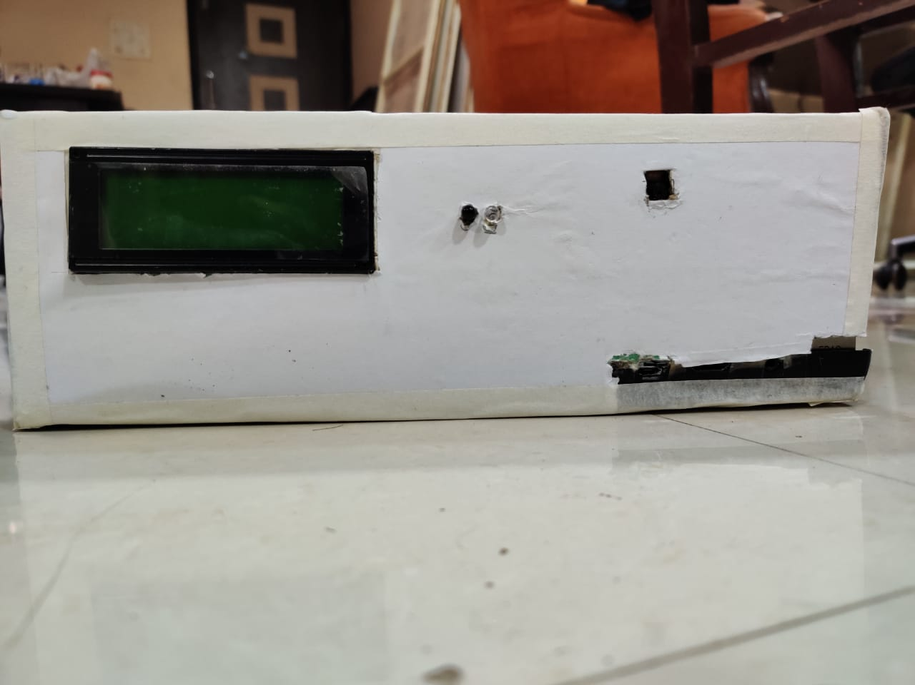

TOP VIEW OF THE PROJECT

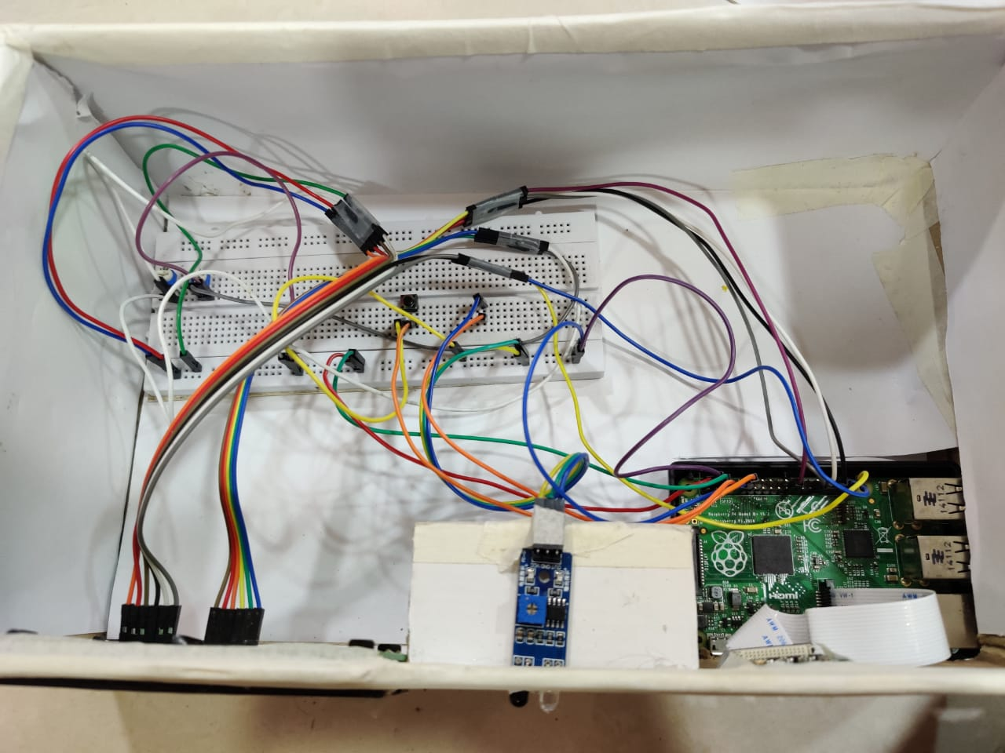

THE SIDE VIEWS AND THE BOTTOM VIEWS ARE TEMPORARILY NOT INCLUDED AND WILL BE INCLUDED IN THE FUTURE.

WE HAVE CREATED THIS PROJECT IN THIS CARDBOARD BOX AS WE HAD TO DISPLAY IT TO EXTERNAL EXAMINER.

THE CARDBOARD BOX REPESENTS A HOUSE, WHERIN THE CONNECTIONS ARE DONE INSIDE THE HOUSE AND ONLY THE SCREEN AND THE INFRARED SENSOR (IR) ARE VISIBLE OUTSIDE OF THE HOUSE.